# **Lab 6. Research on AC drive PWM converters**

Student name: ______Li Xin______ Date of submission____2025.4.10_

HDU ID ____22320404______ Student ITMO ID_____375334_

* LAB#6 is aimed at study Sine PWM and Delta PWM
* LAB#6 is performed in MATLAB / Simulink

# **Task 1.** Perform simulation with sine wave PWM. Compare ideal and converter power sources

Drive parameters:

f_e =100 - nominal frequency, Hz

I_n =1.58 - nominal current, А

Lm =0.624 - mutual inductance H

Ls =0.000663 - stator inductance H

Lr =0.0007015 - rotor inductance, H

Rs =16.39 - stator resistance Оhm

Rr =15.08 - rotor resistance, Оhm

J =0.00108 - moment of inertia, kg*m2

Pn =550 - rated power W

s_n =0.075 - nominal slip

z =4 - pairs of poles

Tn = 3.7853 - rated torque load Nm

Nominal speed: 1197 (RPM)

Required speed: 1197 (RPM)

## 1.1 Provide speed-torque transients with fundamental frequency *fe* (sine wave PWM, ideal source + converter source)

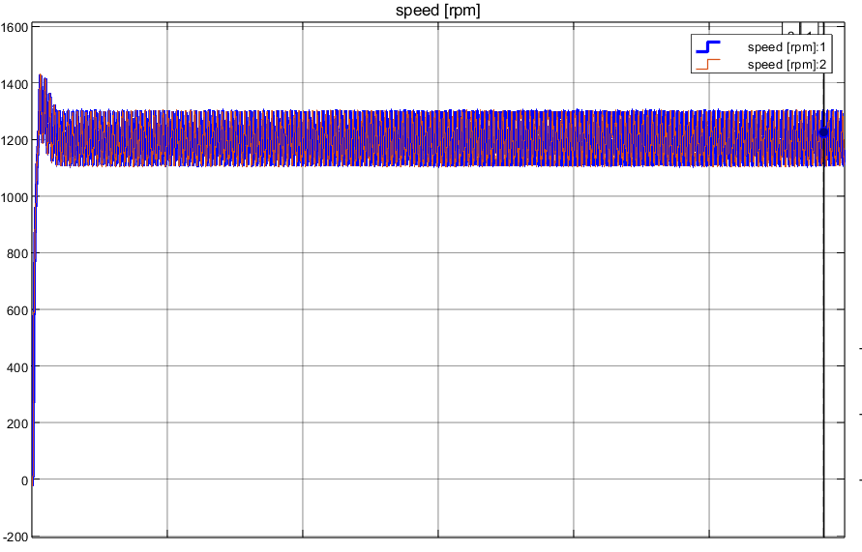

Figure 1 - Mechanical characteristics - for sine wave modulation at nominal (rated) *nrated* speed with ideal source

## 1.2 Provide sine-wave PWM results for the with fundamental frequency *fe* (sine wave PWM, ideal source + converter source)

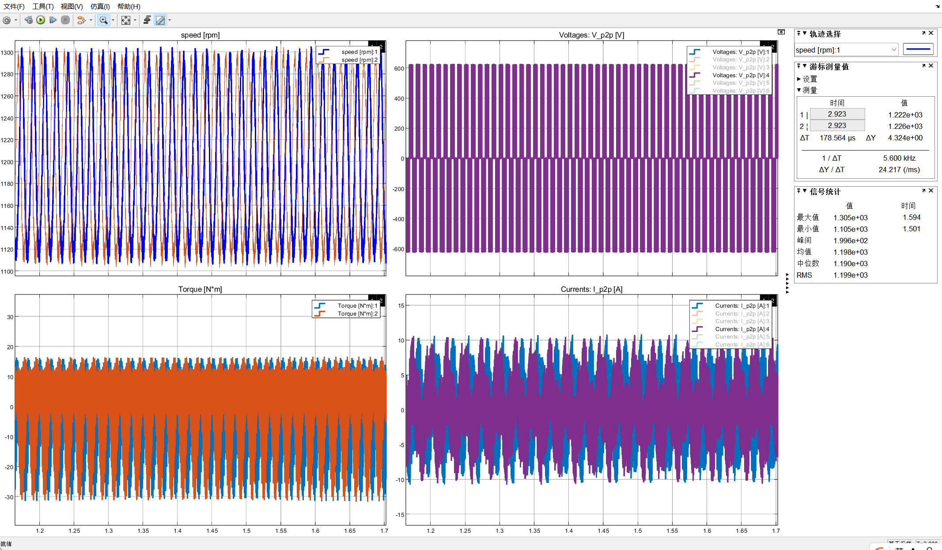

Figure 2 - Mechanical characteristics and PWM sine wave modulation at nominal (rated) speed *nrated* with real converter and ideal source

## 1.3 Provide speed-torque transients at the second required speed with fundamental frequency *fref* (sine wave PWM, ideal source + converter source)

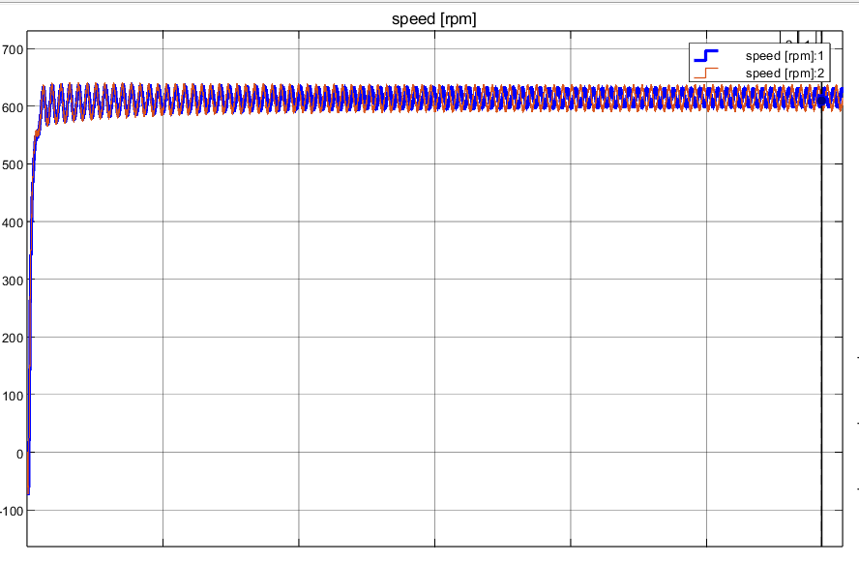

Figure 3 - Mechanical characteristics - for sine wave modulation at the second required speed *nref* speed with real converter and ideal source

## 1.4 Provide sine-wave PWM results for the second required speed with fundamental frequency *fref* (sine wave PWM, ideal source + converter source)

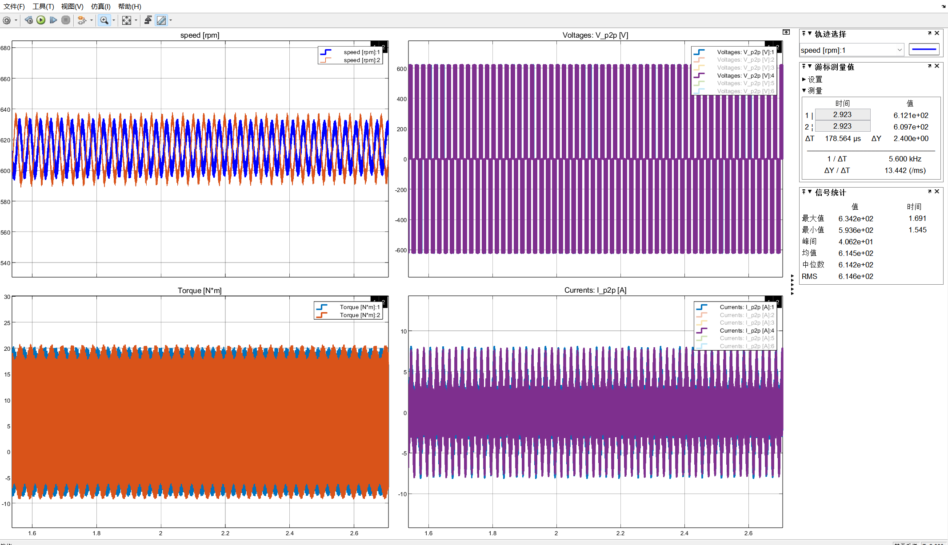

Figure 4 - Mechanical characteristics and PWM sine wave modulation at the second required speed *nref* with real converter and ideal source

## 1.5 Upload screenshots of the FFT analysis Vp2p

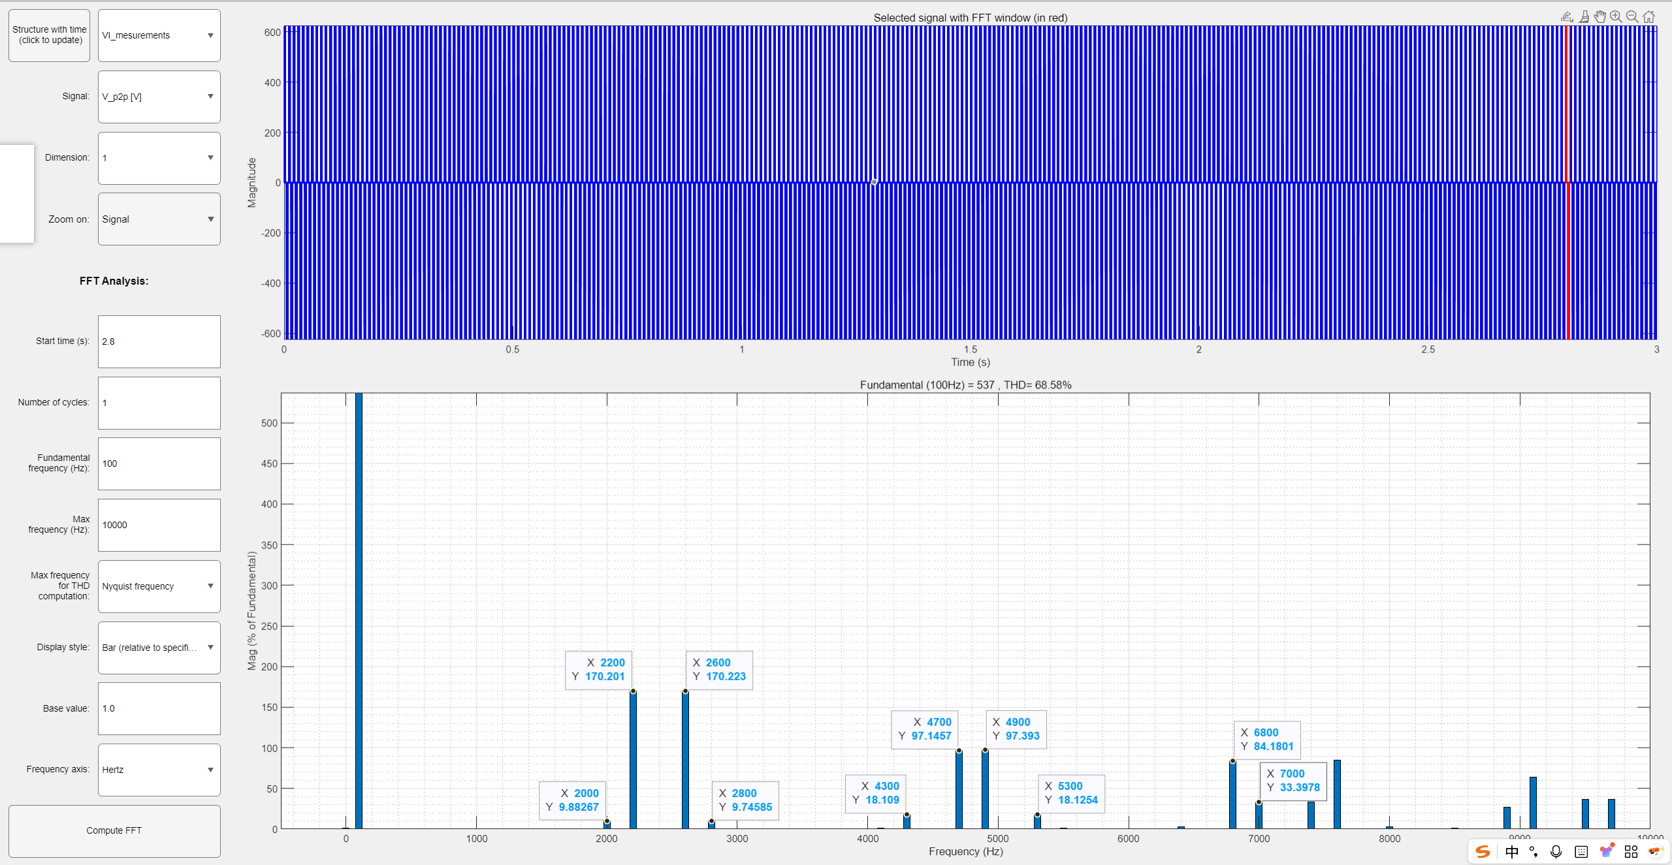

a) for sine wave modulation at nominal speed with real power source

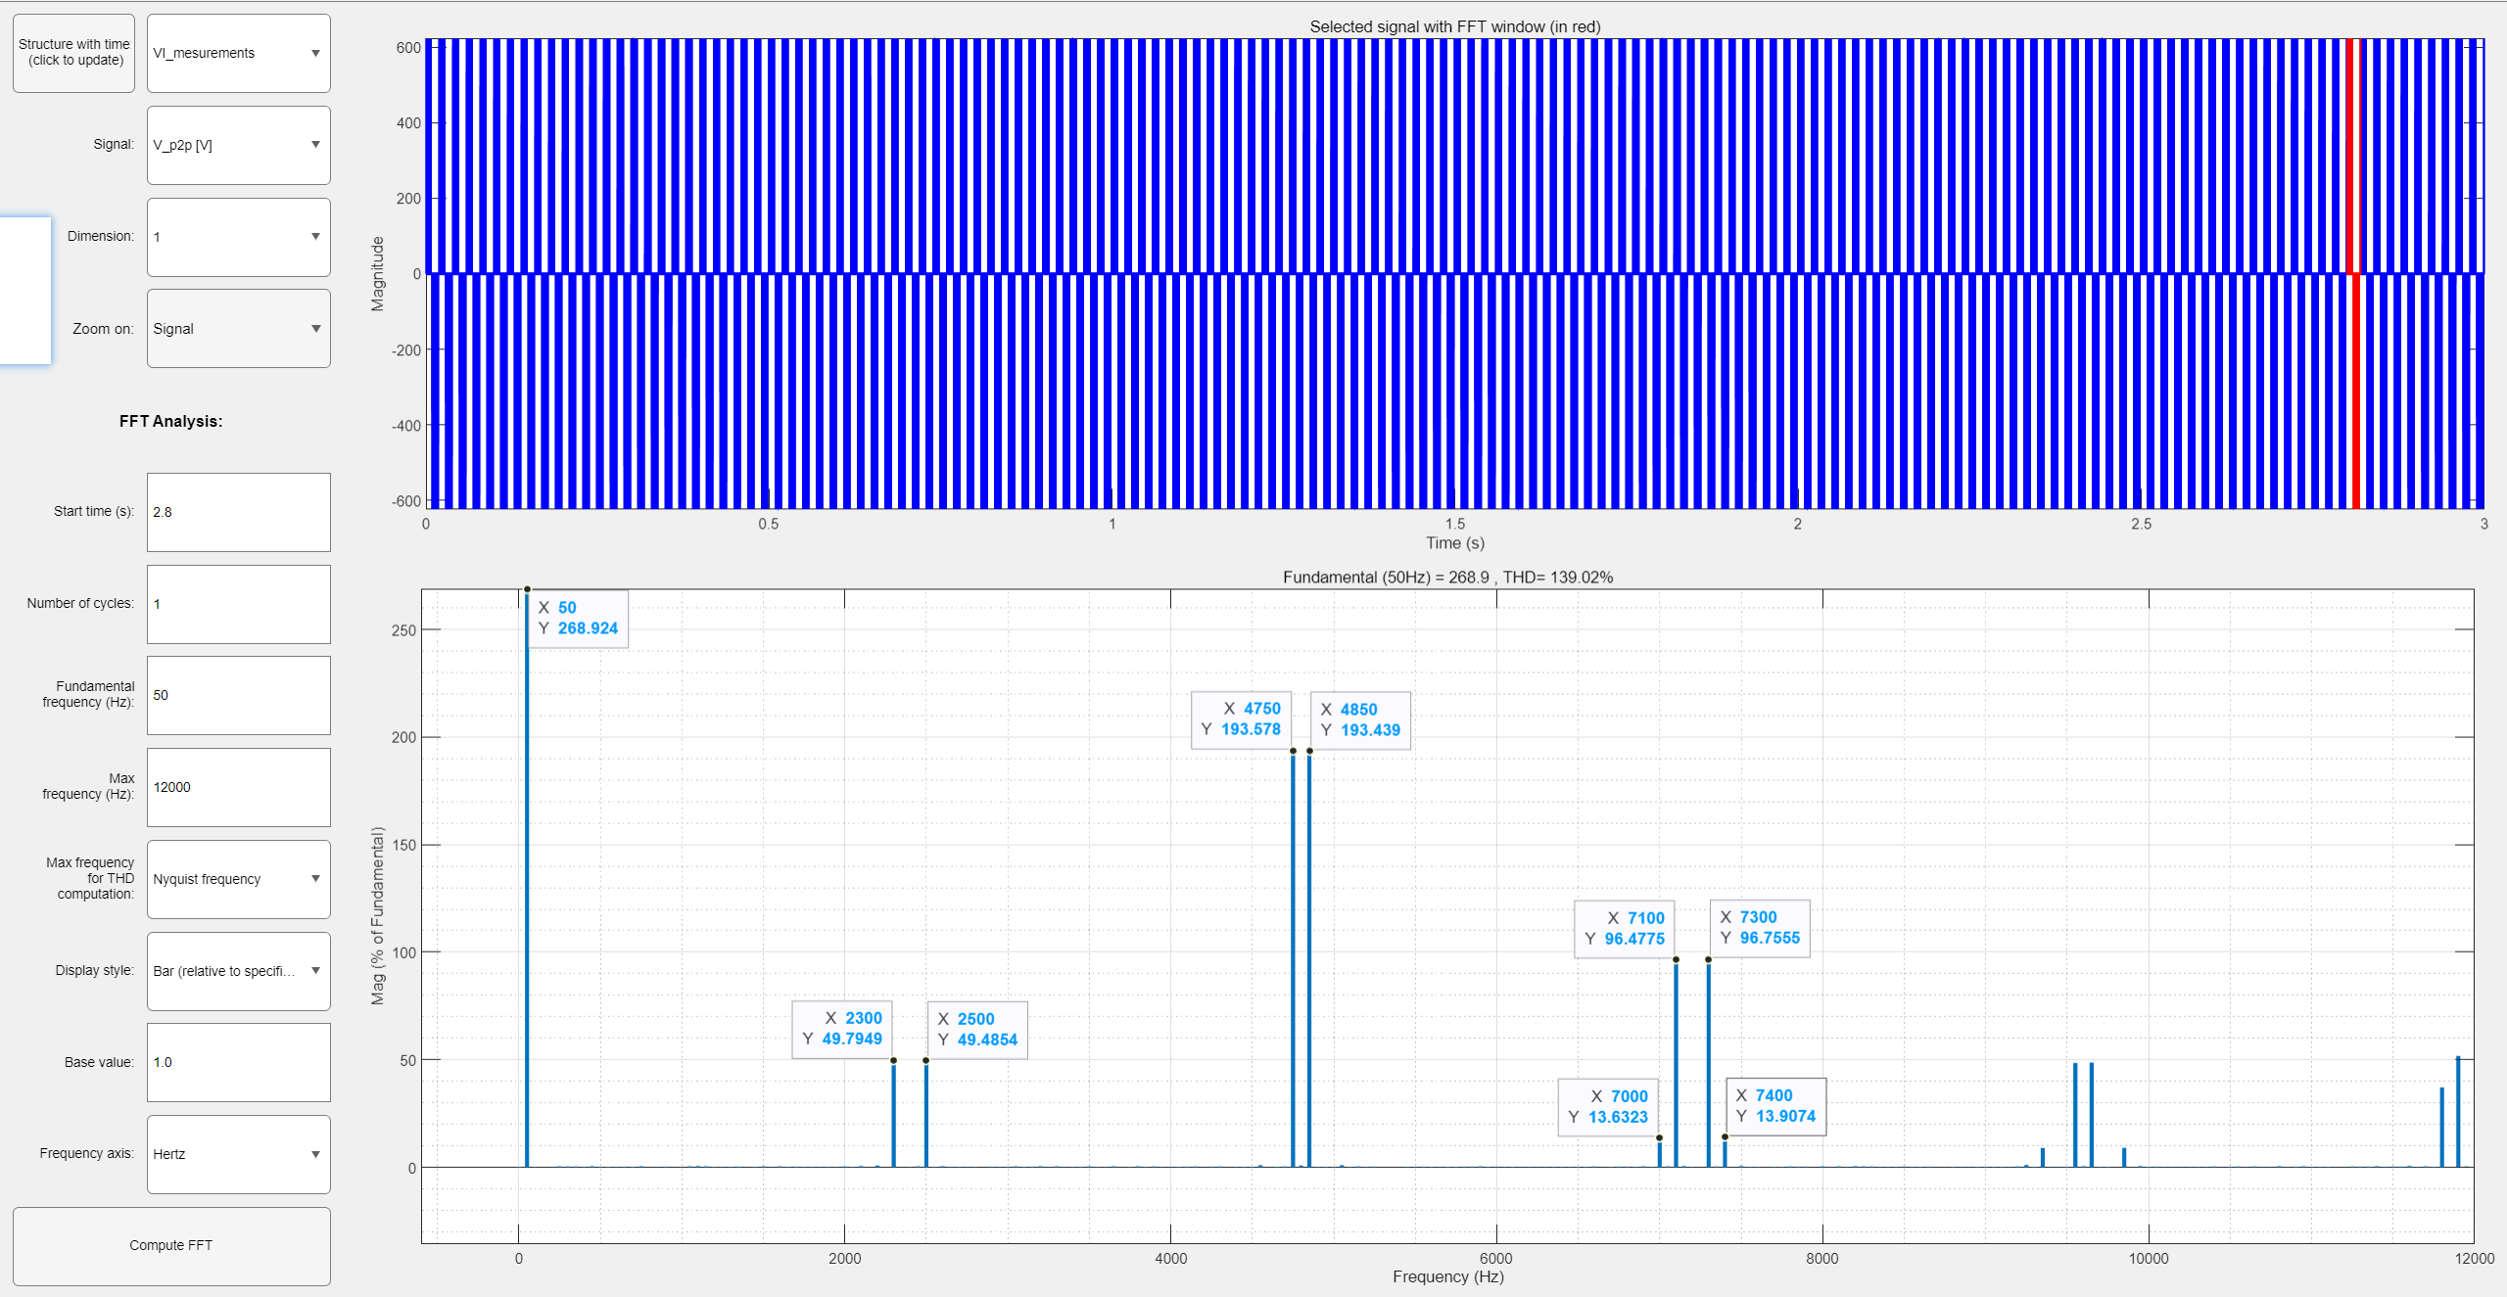

b) for sine wave modulation at the second required speed with real power source

Figure 5 - FFT analysis Vp2p

## 1.6 Upload screenshots of the FFT analysis V_phase

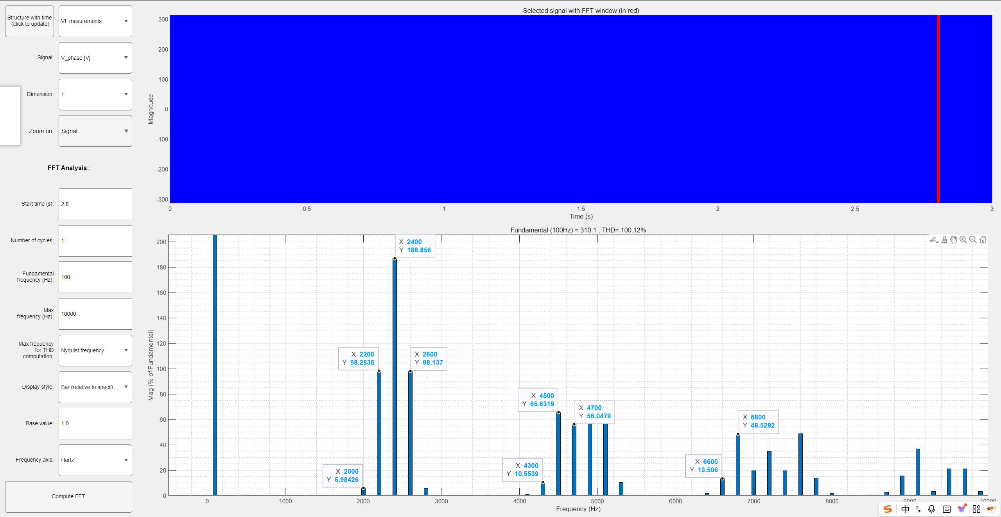

a) for sine wave modulation at nominal speed with real power source

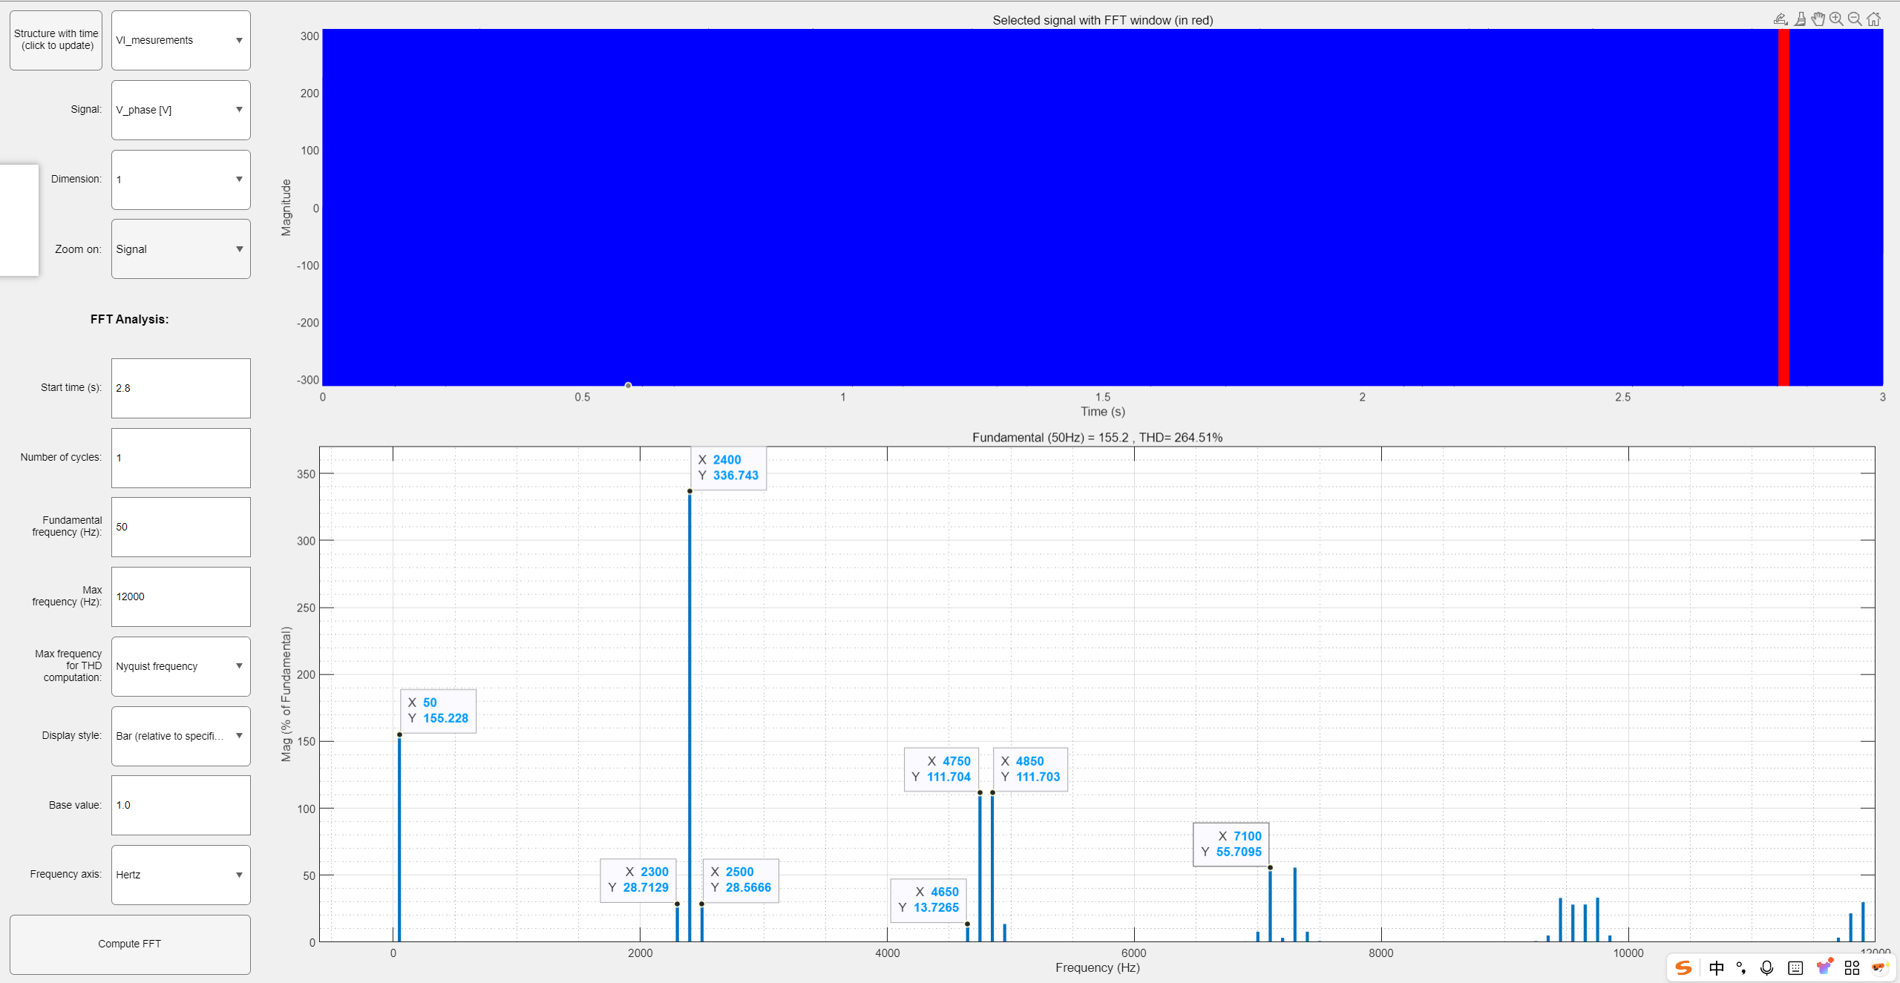

b) for sine wave modulation at the second required speed with real power source

Figure 6 - FFT analysis Vphase

# Conclusions.

In this laboratory work, we studied the operation principles and characteristics of AC drive systems based on Sine Pulse Width Modulation (Sine PWM) using both ideal and converter power sources. Through simulation in Simulink, we analyzed system behavior under rated and reference speed conditions.

From the mechanical characteristic curves, it is evident that both the ideal and converter-based sources can successfully drive the motor at the rated speed (1197 RPM). However, the converter source introduces slight distortions due to the presence of switching harmonics. These were further examined using FFT analysis of both the line voltage Uab, phase voltage Uag, and current Ia.

At both rated and reference speeds, the ideal source provided pure sine waveforms, while the converter source showed a spectrum with clear harmonic components, mainly due to the switching frequency and its multiples. Despite these harmonics, the motor maintained stable operation, indicating that the Sine PWM method is effective in practical converter applications.

Moreover, the frequency modulation index m_f=f_sw/f_s and the modulation index MI were explored to understand their influence on harmonic suppression. As noted in the guideline, higher m_f values lead to better harmonic suppression of lower-order harmonics, though may increase higher-order ones.

Overall, the lab demonstrated that while converter-based Sine PWM introduces harmonic distortion, it remains a viable and efficient method for controlling AC drives in real-world applications.